MultiFe — Software Design Specification
Oct 8, 2026 · @SMAK
Companion to Doc.
MultiFe is built as one Next.js application on Vercel, backed by Supabase. The three panels (Customer, Seller, Admin) are route groups in the same codebase. Data isolation is enforced in the database with Row-Level Security, not only in application code. AI sizing runs in the customer's browser, so it costs nothing per scan. This SDS turns the SRS requirements into components, data structures, interfaces and deployment.

1. Design Overview

1.1 Design goals
- Low running cost: stay within the quoted USD 55–70 a month in Phase 1 by using managed services and paying nothing per scan for AI.
- Ship in 10 weeks: one codebase, one language (TypeScript) end to end, and managed auth, storage and realtime instead of custom services.
- Isolation by default: a bug in a page or an API call must not leak one shop's data to another. RLS makes the database the last line of defence.
- Phone first: the storefront is served from the edge, optimised for a mid-range Android phone over 4G.
- Replaceable parts: the AI engine, payment gateway and WhatsApp provider sit behind interfaces, so a vendor can change without touching the order flow.

1.2 Key design decisions
# | Decision | Alternatives considered | Reason
D1 | Modular monolith in Next.js (App Router) | Separate frontend + Node/NestJS API; microservices | Fastest to build and run for 1–2 developers; Vercel deploys it with no ops work
D2 | Supabase for Postgres, Auth, Storage, Edge Functions, Realtime | Firebase; self-hosted Postgres + custom auth | Relational data fits orders and catalogues; four services in one USD 25 plan
D3 | Multi-tenancy by shop_id column + RLS, in one shared database | A schema or a database per shop | Simple, cheap, and scales to hundreds of shops
D4 | On-device pose estimation (MediaPipe / MoveNet) for sizing | Commercial API (3DLOOK, Bodygram, Mirrorsize) | USD 0 per scan against about USD 1–3 a scan; images can stay on the phone
D5 | Shop storefronts at path URLs /s/{slug} | A subdomain per shop | No wildcard DNS or certificates; QR codes stay simple. Custom domains can be added later
D6 | Writes through Next.js Server Actions and Route Handlers; reads through supabase-js with RLS | REST-only API layer | Less code; business rules (status changes, pricing) stay on the server
D7 | Order status changes only through one server function that checks allowed transitions | Updating the status column directly from the client | One place enforces the lifecycle, writes history and triggers notifications
D8 | Notifications sent asynchronously from a database outbox table | Calling email/WhatsApp inside the request | A slow or failing provider doesn't block the order, and failed sends are retried

2. System Architecture
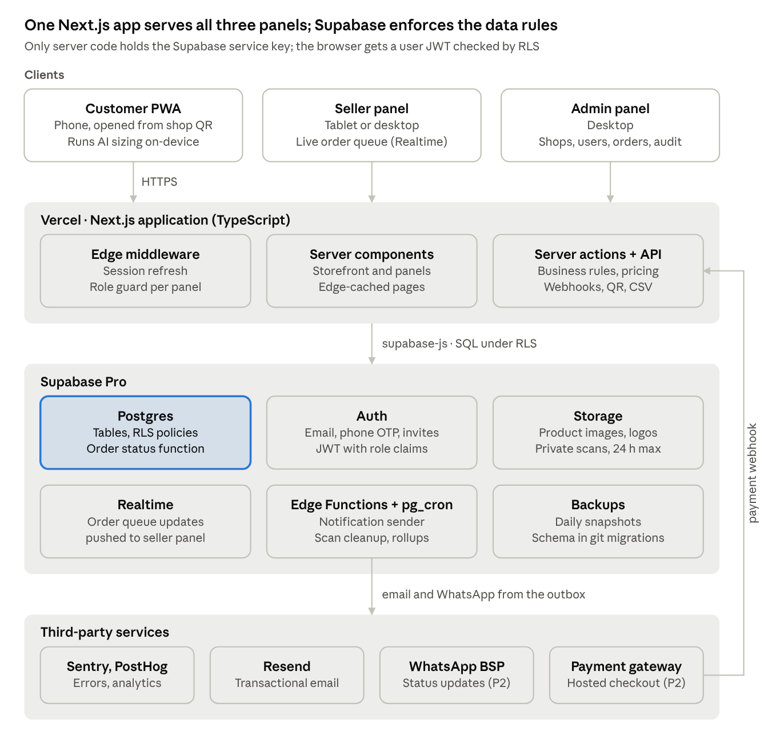
system architecture · clients, Vercel, Supabase, third parties
Requests flow top-down: clients call the Next.js app on Vercel, which reads and writes Supabase under RLS. Background jobs in Supabase send email and WhatsApp messages, and the payment gateway calls back into the app by webhook. The browser also talks to Supabase directly for sign-in and the seller's realtime order queue, using the user's own JWT. Cloudinary joins later as the image service once the catalogue grows.

2.1 Components
Layer | Component | Technology | Responsibility
Presentation | Customer PWA, Seller panel, Admin panel | Next.js + React + Tailwind | UI per role; PWA install and offline catalogue for customers
Presentation | Sizing client | MediaPipe Pose Landmarker / TF.js MoveNet (WASM) | Pose landmarks and measurement maths in the browser
Application | Middleware | Next.js middleware (edge) | Session refresh, role-based routing
Application | Pages | React Server Components | Render storefront and panels; edge cache
Application | Server actions, route handlers | Next.js (Node runtime) | Validation, pricing, order placement, webhooks, QR and CSV
Data | Database | Supabase Postgres | All business data; RLS; status transition function; outbox
Data | Auth | Supabase Auth | Accounts, OTP, invites, JWT with role claims
Data | File storage | Supabase Storage | Product images, shop logos, temporary scan images
Data | Realtime | Supabase Realtime | Push new orders and status changes to open screens
Background | Jobs | Supabase Edge Functions + pg_cron | Notifications, scan cleanup, stale-order alerts, stats
External | Messaging | Resend; WhatsApp BSP | Email; WhatsApp status messages
External | Payments | Gateway to be chosen | Hosted checkout, refunds, webhooks
External | Operations | Sentry, PostHog, GitHub | Errors, analytics, source control and CI

2.2 Architecture style
- Modular monolith: one deployable app, split into domain modules (§3.2) with clear boundaries, so a module can be pulled out into its own service later if needed.
- Shared database, tenant column: every shop-owned row carries shop_id; RLS policies filter by it (§8.2).
- Event outbox: state changes write a row to notification_outbox in the same transaction; a job sends the messages (D8).
- Ports and adapters at the vendor edges: SizingEngine, MessageChannel, PaymentGateway (§3.4).

3. Application Design

3.1 Codebase structure
One Next.js 15 (App Router) repository in TypeScript. Route groups split the three panels, and middleware sends each role to its own panel.
multife/
├─ app/
│ ├─ (storefront)/s/[shopSlug]/ # public storefront, product, cart, checkout
│ ├─ (customer)/account/ # orders, measurement profiles, profile
│ ├─ (customer)/measure/ # AI scan + manual entry
│ ├─ (seller)/seller/ # dashboard, orders, catalogue, staff, shop settings
│ ├─ (admin)/admin/ # shops, users, orders, categories, templates, audit
│ ├─ (auth)/ # sign-in, sign-up, invite accept, reset
│ └─ api/ # route handlers: webhooks, QR image, CSV export
├─ modules/ # domain logic, framework-free
│ ├─ catalog/ orders/ measurements/ shops/ users/
│ ├─ notifications/ payments/ sizing/
├─ lib/supabase/ # server, browser, admin clients; generated DB types
├─ components/ # shared UI (Tailwind)
├─ supabase/
│ ├─ migrations/ # SQL schema, RLS policies, functions
│ └─ functions/ # Edge Functions: notify-dispatch, scan-cleanup, payment-webhook
└─ middleware.ts # session refresh + role-based route guard

3.2 Modules
Module | Responsibility | Main operations | SRS
shops | Shop profile, branding, slug, QR, staff | createShop, updateBranding, inviteStaff, generateQr | FR-SEL-01/02/09, FR-ADM-01/02
users | Profiles, roles, suspension | getProfile, updateProfile, suspendUser | FR-AUTH-01–07, FR-ADM-03
catalog | Categories, products, option groups, images, stock | listProducts, upsertProduct, setAvailability | FR-CUS-03–05, FR-SEL-03/04, FR-ADM-05/06
cart | One-shop cart, price calculation | addItem, updateItem, priceCart | FR-CUS-06
measurements | Profiles, templates, AI results, shopkeeper corrections | saveProfile, approveMeasurements | FR-CUS-08/09, FR-SEL-06
sizing | In-browser pose detection and measurement calculation | runScan, computeMeasurements | FR-AI-01–07
orders | Checkout, order snapshot, status transitions, history | placeOrder, transitionStatus, cancelOrder | FR-ORD-01–05, FR-SEL-07
payments | Offline marking, gateway checkout, webhooks, refunds | createPaymentIntent, handleWebhook, markPaid | FR-PAY-01–04
notifications | Outbox, templates, email/WhatsApp providers | enqueue, dispatch | FR-NOT-01–04
reporting | Seller and admin dashboards | shopStats, platformStats | FR-SEL-10, FR-ADM-07
audit | Records admin and sensitive actions | log | FR-ADM-10

3.3 Rendering strategy
Surface | Rendering | Caching
Storefront and product pages | Server components, static with on-demand revalidation | Edge cache; revalidated by tag when the shop edits a product
Cart, checkout, measurement | Client components | No cache; cart kept in the database for signed-in users, localStorage for guests
Seller order queue | Server render + Supabase Realtime subscription | Live
Admin tables | Server components with server-side paging | None

3.4 Provider interfaces
The parts that can change vendor sit behind small TypeScript interfaces, with one adapter per vendor:
- SizingEngine: estimate(input) → MeasurementResult. Adapters: MediaPipeEngine (default), ApiEngine (Option B).
- MessageChannel: send(to, template, vars). Adapters: ResendEmail, WhatsAppBsp.
- PaymentGateway: createCheckout(order), verifyWebhook(req), refund(payment). The adapter is picked once the client chooses a gateway.

4. Data Design

4.1 Entity-relationship model
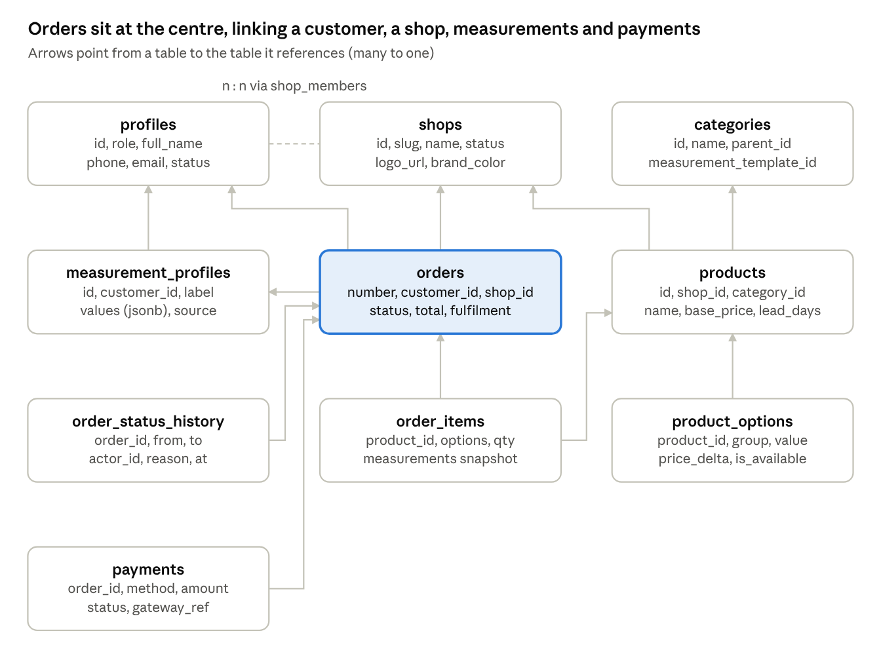
core data model · 10 main tables
Supporting tables not drawn: shop_members, carts, cart_items, product_images, measurement_templates, notification_outbox, notification_templates, scan_deletion_log, audit_log, and reviews (P2).

4.2 Table definitions
All tables have id uuid primary key, created_at and updated_at. Money is stored as numeric(12,2) in PKR. Every table that belongs to a shop has shop_id and RLS (§8.2).
Table | Key columns | Notes
profiles | id (= auth.users.id), role, full_name, phone, email, status | role: customer, shopkeeper, admin; status: active, suspended
shops | slug (unique), name, logo_url, brand_color, address, phone, hours, fulfilment_modes, status | status: pending, active, suspended
shop_members | shop_id, user_id, member_role | member_role: owner, staff; unique (shop_id, user_id)
categories | name, parent_id, measurement_template_id, sort | Managed by admin
measurement_templates | name, fields (jsonb: key, label, unit, min, max, guide_image) | Which measurements a garment type needs
products | shop_id, category_id, name, description, base_price, lead_days, is_published | Index (shop_id, is_published)
product_images | product_id, url, sort | Storage path or Cloudinary URL
product_options | product_id, group (fabric, collar, sleeve…), value, price_delta, is_available | Customer picks one value per group
measurement_profiles | customer_id, label, values (jsonb), source, confidence (jsonb) | source: ai, manual, shop_corrected
carts, cart_items | customer_id, shop_id; product_id, options, qty | One shop per cart
orders | number (unique), customer_id, shop_id, measurement_profile_id, status, fulfilment, address, subtotal, total, payment_status, measurements_approved_by, measurements_approved_at, est_ready_date | Index (shop_id, status, created_at)
order_items | order_id, product_id, product_name, options (jsonb), unit_price, qty, measurements (jsonb) | Snapshot: later product or profile edits do not change it
order_status_history | order_id, from_status, to_status, actor_id, reason | Written only by fn_transition_order
payments | order_id, method, amount, status, gateway_ref, event_id (unique) | method: cod, pay_at_shop, online; event_id makes webhooks idempotent
notification_outbox | order_id, channel, recipient, template, payload, status, attempts, next_attempt_at | status: pending, sent, failed
notification_templates | key, channel, subject, body | Editable by admin (P2)
scan_deletion_log | run_at, files_deleted | Proof of the 24-hour policy
audit_log | actor_id, action, entity, entity_id, before, after | Admin and sensitive actions
reviews (P2) | order_id, customer_id, shop_id, rating, comment, is_hidden | One per completed order

4.3 Storage buckets
Bucket | Access | Contents
public-media | Public read; write by shop members for their own shop_id/ folder | Product images, shop logos
scans | Private; signed URLs only | Optional scan photos for review, deleted within 24 hours
exports | Private | CSV exports, deleted after 7 days

5. Order Lifecycle
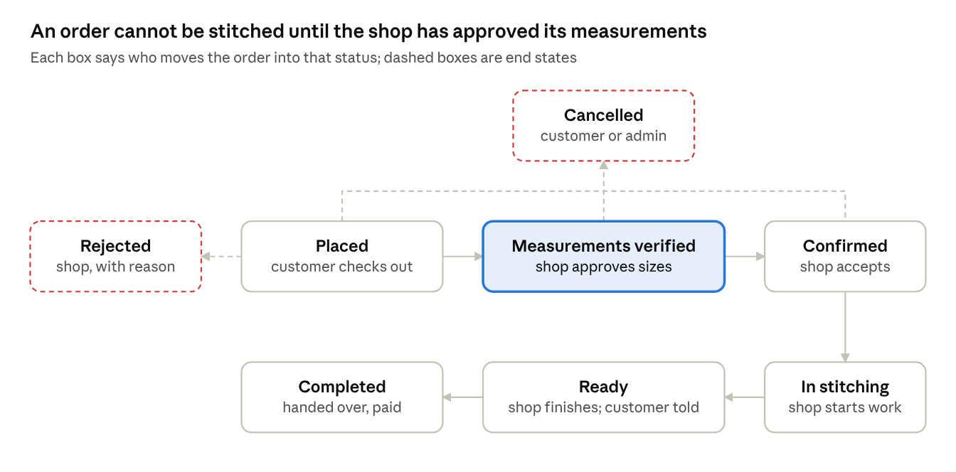
order status lifecycle · 6 steps, 2 end states
Orders move only through fn_transition_order(order_id, to_status, reason), a Postgres function that runs as one transaction. It checks the caller's role and the allowed move, updates the order, writes order_status_history, and adds the matching messages to notification_outbox. Any other move is refused.
From | To | Who | Guard | Side effects
— | Placed | Customer | Cart re-priced on server; measurement profile chosen | Order number assigned; snapshot saved; "order placed" email; realtime alert to shop
Placed | Measurements verified | Shopkeeper | All template fields present and within min/max | Approved values, approver and time saved on the order
Placed | Rejected | Shopkeeper | Reason required | Customer notified; online payment refunded
Measurements verified | Confirmed | Shopkeeper | Online orders: payment status = paid | Estimated ready date set from lead time; "confirmed" email/WhatsApp
Confirmed | In stitching | Shopkeeper | — | Customer can no longer cancel
In stitching | Ready | Shopkeeper | — | "Ready" email/WhatsApp
Ready | Completed | Shopkeeper | Offline orders: marked paid | "Completed" WhatsApp; review invite (P2)
Placed, Measurements verified, Confirmed | Cancelled | Customer | Before In stitching | Shop alerted; online payment refunded
Any status before Completed | Cancelled | Admin | Reason required | Audit log entry; both sides notified

6. AI Sizing Engine Design
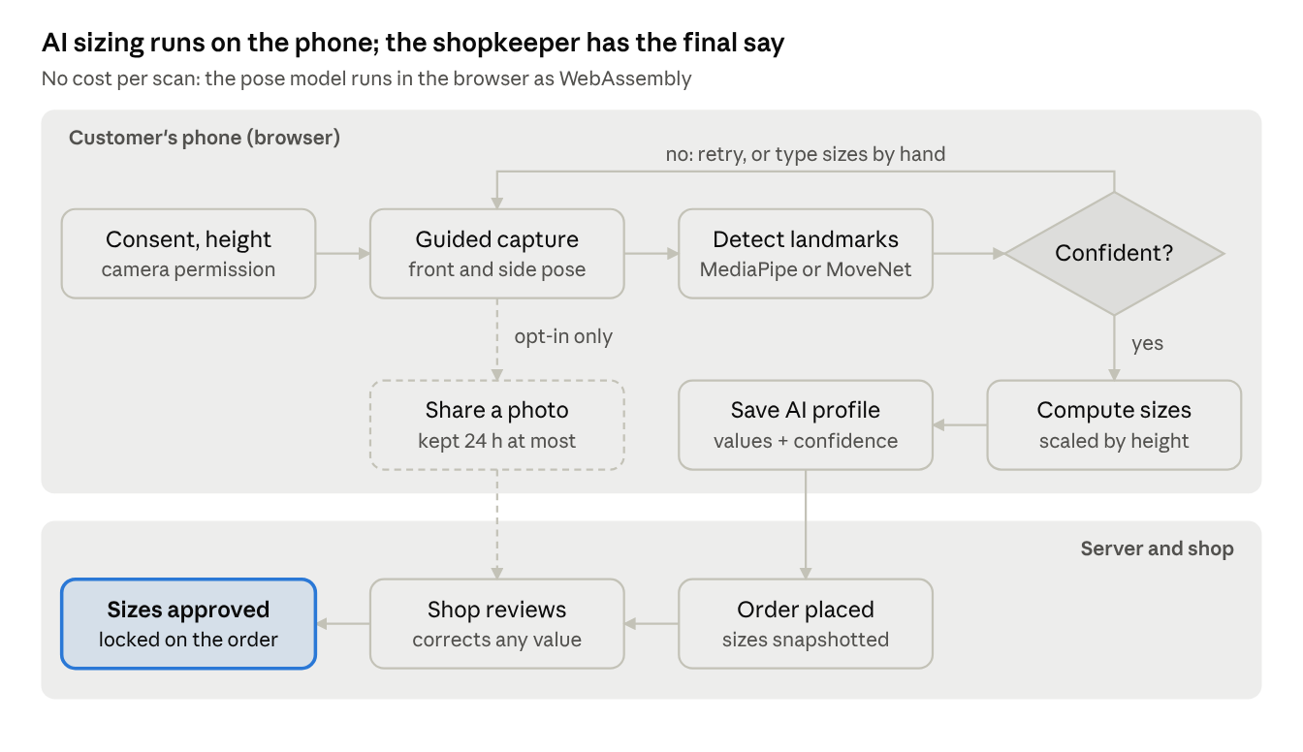
AI sizing pipeline · phone to approved sizes
The engine follows Option A from the quotation: pose estimation in the browser, at no cost per scan. Accuracy is moderate, which is acceptable because every order passes the shopkeeper's review before stitching.

6.1 Pipeline
- Consent and calibration: the customer agrees to camera use and enters their height (or places a reference object of known size, such as an A4 sheet, in frame). Height gives the scale from pixels to centimetres.
- Guided capture: a full-screen camera view with an outline overlay guides a front pose and a side pose. Live checks (whole body in frame, distance, lighting, pose held still) decide when to capture.
- Landmark detection: MediaPipe Pose Landmarker (default) or TensorFlow.js MoveNet, compiled to WASM, finds 33 / 17 body landmarks with a visibility score each. The model (about 10 MB) loads from a CDN on first use and is then cached.
- Quality gate: if key landmarks (shoulders, hips, knees, ankles, wrists) fall below the visibility threshold, the customer is asked to retry, or can switch to manual entry.
- Measurement calculation: lengths (shoulder width, sleeve, inseam, back length) come from distances between landmarks scaled by height. Girths (chest, waist, hip) are estimated from front width and side depth with an ellipse model and correction factors. The factors are tuned during Phase 2 against tape measurements.
- Save: the result is saved as a measurement profile with source = ai and a confidence value per field. Fields required by the garment's template but not derivable (e.g. neck) are left for manual entry.
- Shop review: the shopkeeper sees AI values side by side with the template's allowed ranges. Low-confidence fields are highlighted. They correct values and approve them, which locks the values on the order.

6.2 Interface
interface SizingEngine {
estimate(input: {
frames: { front: ImageBitmap; side: ImageBitmap };
heightCm: number;
template: MeasurementTemplate;
}): Promise<{
values: Record<string, number>; // cm
confidence: Record<string, number>; // 0–1
engine: 'mediapipe' | 'movenet' | 'api';
}>;
}
The ordering flow depends only on this interface. A commercial API (Option B: 3DLOOK, Bodygram or Mirrorsize) can replace the on-device engine through an ApiEngine adapter. That adapter would upload images, so it would also need the 24-hour deletion path.

6.3 Privacy
By default no image leaves the phone: frames are processed in memory and discarded. Uploading a photo for the shop's review is opt-in. It goes to the private scans bucket, and the hourly scan-cleanup job deletes it within 24 hours (§7.2, §8.3).

7. API and Integration Design

7.1 Server actions and route handlers
Reads go straight to Supabase from server components, with RLS applied. Writes that carry business rules go through server actions, which validate input with Zod and run in a database transaction where several tables change.
Operation | Type | Caller | What it does
placeOrder(cartId, profileId, fulfilment, payment) | Server action | Customer | Re-prices the cart on the server, snapshots items and measurements, creates the order as placed, empties the cart, enqueues "order placed"
approveMeasurements(orderId, values) | Server action | Shopkeeper | Saves corrected values on the order, marks them approved with approver and time, moves the order to measurements_verified
transitionStatus(orderId, to, reason?) | Server action → DB function | Shopkeeper, Admin, Customer (cancel only) | Calls fn_transition_order, which checks the role and the allowed transition, writes history and outbox in one transaction
upsertProduct(input) | Server action | Shopkeeper | Validates, saves the product, options and images, revalidates the storefront cache tag
inviteUser(email, role, shopId?) | Server action | Admin, shop owner | Creates the invite through Supabase Auth admin API and sends the email
GET /api/shops/[slug]/qr | Route handler | Shop owner | Returns the shop's QR code as PNG or PDF
GET /api/seller/orders.csv | Route handler | Shopkeeper | Streams the shop's orders as CSV (P2)
POST /api/webhooks/payment | Route handler | Payment gateway | Checks the signature, records the payment once (idempotent), marks the order paid
POST /api/webhooks/whatsapp | Route handler | WhatsApp BSP | Checks the signature, updates message delivery status, records opt-outs

7.2 Background jobs (Supabase Edge Functions + pg_cron)
Job | Trigger | What it does
notify-dispatch | Every minute, and on insert into notification_outbox | Sends pending messages through the right channel, retries up to 5 times with back-off, then marks them failed
scan-cleanup | Every hour | Deletes scan images older than 24 hours from the private scans bucket and writes the count to scan_deletion_log
stale-order-alert | Daily | Flags orders stuck in one status longer than the shop's lead time, for the seller and admin dashboards
stats-rollup | Nightly | Refreshes materialised views for the seller and admin dashboards

7.3 Third-party integrations
Integration | Direction | Notes
Resend | Outbound REST | Verified sending domain (SPF, DKIM); free tier is 3,000 a month with a 100-a-day cap, so move to Pro before Phase 2 volume
WhatsApp via BSP | Outbound REST + inbound webhook | Only pre-approved templates (order confirmed, ready, completed); one message is about USD 0.06
Payment gateway | Redirect to hosted checkout + inbound webhook | Order reference sent as metadata; the webhook is the only source of truth for "paid"
Cloudinary (deferred) | URL-based delivery | When the catalogue grows, product images move from Supabase Storage to Cloudinary; the image component already takes a loader
Sentry, PostHog | SDKs | No measurement values or personal data sent to either

8. Security Design

8.1 Authentication and roles
- Supabase Auth issues a JWT on sign-in. The user's role and shop_id are added to the JWT as custom claims by an auth hook that reads profiles and shop_members.
- middleware.ts refreshes the session on each request and blocks /seller/* and /admin/* for the wrong role. RLS checks again in the database, so a bypassed page still returns no data.
- Shopkeepers and admins only join by invite. Customers can sign up by email or phone OTP. Sign-in and OTP requests are rate-limited.
- The Supabase service-role key is used only in server code and Edge Functions, never in the browser.

8.2 Row-Level Security policies (summary)
Table | Customer | Shopkeeper | Admin | Public (guest)
shops | Read active | Read/update own shop (owner only for branding) | All | Read active shops
products, product_options | Read published | All on own shop's rows | All | Read published of active shops
carts, cart_items | Own rows only | None | Read | None
measurement_profiles | Own rows only | Read profiles attached to own shop's orders | Read | None
orders, order_items | Own orders | Own shop's orders; update only through fn_transition_order | All | None
order_status_history | Own orders | Own shop's orders | All | None
payments | Own orders | Own shop's orders | All | None
audit_log | None | None | Read | None
RLS tests run in CI: for each table, a test signs in as a user of Shop A and checks that every row from Shop B is hidden (SRS acceptance criterion 2).

8.3 Privacy and scan images
- By default the AI scan uses camera frames in memory only. No image is uploaded.
- If the customer agrees to share a photo for the shopkeeper's review, it goes to a private scans bucket under {order_id}/. It is shown only through signed URLs that expire in 10 minutes. The scan-cleanup job deletes it within 24 hours.
- Measurements are personal data. They are visible only to the customer, the shop of that order, and admins. They are never sent to analytics or error tracking.

8.4 Application security
- Every server action checks its input with Zod. Server code never trusts prices sent from the client.
- Next.js protects server actions against CSRF. Webhooks are verified by HMAC signature and timestamp, and stored with a unique event ID so a replay is ignored.
- Security headers: CSP, HSTS, X-Frame-Options DENY, Referrer-Policy. Uploads are checked for type and size (images only, at most 5 MB).
- The payment gateway's hosted page handles card data, which keeps PCI scope at SAQ-A.

9. Deployment and Operations

9.1 Environments
Environment | Frontend | Backend | Data | Purpose
Local | next dev | Supabase CLI (local Docker) | Seed data | Development
Preview | Vercel preview per pull request | Supabase staging project | Seed + test data | Review and QA
Production | Vercel Pro, production domain | Supabase Pro project | Live data | Customers

9.2 CI/CD
- A pull request on GitHub runs GitHub Actions: type check, lint, unit tests, RLS tests against a local Supabase.
- Vercel builds a preview deployment for the pull request.
- On merge to main, supabase db push applies new migrations to production, then Vercel deploys production.
- Rollback: Vercel instant rollback for the app. Every migration is written to be backward compatible with the previous app version (add first, remove in a later release).

9.3 Observability
- Errors: Sentry on browser, server and Edge Functions, with source maps and release tags. Alerts go to the team on new error types.
- Product analytics: PostHog funnels for QR scan → product view → measured → order placed, and scan success rate.
- Uptime: an external check on the storefront and on /api/health every 5 minutes.
- Logs: Vercel and Supabase logs. The notification outbox and scan deletion log can be checked from the admin panel.

9.4 Performance
- Storefront pages are served from Vercel's edge cache and revalidated when the shop changes a product.
- Images are served by next/image (later Cloudinary) in WebP/AVIF at the right size for the screen.
- The pose model (about 10 MB) loads only on the measurement page, and is cached by the service worker after the first use.
- Indexes are set on orders(shop_id, status, created_at), products(shop_id, is_published) and order_status_history(order_id). Admin lists are paged on the server.

9.5 Backup and recovery
- Supabase Pro takes daily backups. Point-in-time recovery is an add-on, worth enabling once order volume grows.
- Migrations live in git, so the schema can be rebuilt from scratch.
- Product images in Storage are not covered by database backups; a weekly copy to a second bucket is recommended.

10. Requirements Traceability
SRS requirements | Design elements (this SDS)
FR-AUTH-01–08 | §8.1 auth and roles; users module; profiles, shop_members tables; middleware
FR-CUS-01, 02 | D5 path routing /s/{slug}; storefront route group; §3.3 edge caching
FR-CUS-03–06, 13 | catalog and cart modules; products, product_options, carts tables
FR-CUS-07–11 | placeOrder, transitionStatus; §5 order lifecycle; orders, order_items tables
FR-CUS-14 | PWA manifest + service worker; §9.4 caching
FR-AI-01–07 | §6 sizing pipeline; SizingEngine interface; scan-cleanup job; §8.3 privacy
FR-SEL-01–04, 09 | shops, catalog modules; QR route handler
FR-SEL-05–08 | Realtime order queue; approveMeasurements; §5 lifecycle
FR-SEL-10–12, FR-ADM-07 | reporting module; stats-rollup job
FR-ADM-01–06, 08–09 | Admin route group; shops, users, catalog modules; notification_templates
FR-ADM-10 | audit module; audit_log table
FR-ORD-01–05 | fn_transition_order; order_status_history; snapshot columns on order_items
FR-NOT-01–04 | D8 outbox; notify-dispatch job; MessageChannel adapters
FR-PAY-01–04 | payments module; PaymentGateway interface; payment webhook
NFR-PERF-* | §9.4 performance; §3.3 rendering
NFR-SEC-, NFR-PRIV- | §8 security design
NFR-AVL-, NFR-OBS- | §9.3 observability; §9.5 backup and recovery
NFR-MNT-* | §3.1 structure; §9.2 CI/CD

